**LMNTS API FUNCTONALITIES**

List all devices: <http://localhost:8000/M2M/machines>

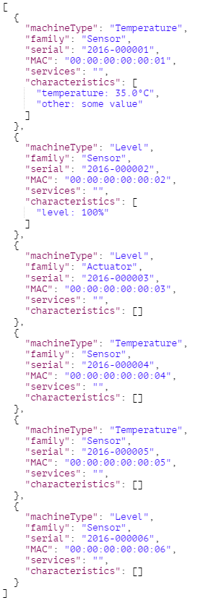

Create a new device: <http://localhost:8000/M2M/machines/>

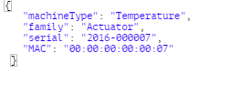

Delete a device giving its serial: <http://localhost:8000/M2M/machines/>



List all family devices: <http://localhost:8000/M2M/machines/actuator>

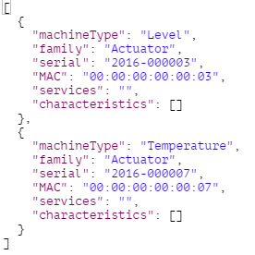

Delete all family devices (e.g. family: actuator): <http://localhost:8000/M2M/machines/actuator/>

List all the same device type (e.g. temperature sensors): <http://localhost:8000/M2M/machines/sensor/temperature>

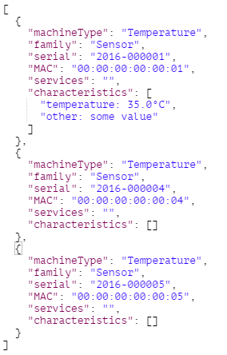

Delete all the same device type: <http://localhost:8000/M2M/machines/sensor/temperature/>

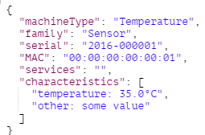List device features by serial: <http://localhost:8000/M2M/machines/sensor/temperature/2016-000001>

Update device information: <http://localhost:8000/M2M/machines/sensor/temperature/2016-000001>

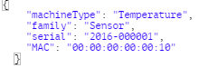

Delete a device by serial: <http://localhost:8000/M2M/machines/sensor/temperature/2016-000005>

Show device feature value: <http://localhost:8000/M2M/machines/sensor/temperature/2016-000001/family>

List device characteristics (short information): <http://localhost:8000/M2M/machines/sensor/temperature/2016-000001/characteristics>

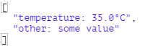

List device characteristics: <http://localhost:8000/M2M/machines/sensor/temperature/2016-000001/Characteristics>

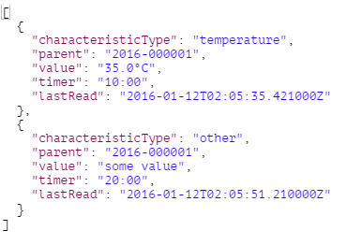

Show a characteristic details: <http://localhost:8000/M2M/machines/sensor/temperature/2016-000001/temperature>

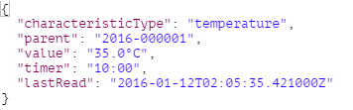

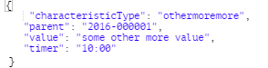Create a new characteristic: <http://localhost:8000/M2M/machines/sensor/temperature/2016-000001/> or <http://localhost:8000/M2M/machines/sensor/temperature/2016-000001/Characteristics/>

Update a characteristic: <http://localhost:8000/M2M/machines/sensor/temperature/2016-000001/temperature/>

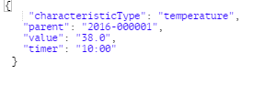

Delete a characteristic: <http://localhost:8000/M2M/machines/sensor/temperature/2016-000001/temperature>

Show characteristic field value: <http://localhost:8000/M2M/machines/sensor/temperature/2016-000001/temperature/value>



Update a characteristic field value: <http://localhost:8000/M2M/machines/sensor/temperature/2016-000001/temperature/value>

